Material Used
We are students at Asmara College of Health Science School of Public Health. We are currently conducting a research titled: Prevalence and Risk factors of suicidal ideation among college students in Eritrea. We kindly request you to volunteer to participate in this study. All information you provide us will be used for the
purpose of this study only and it will be treated with strict confidentiality. Thank you in advance.
Sex = M / F Age________. Address (ZOBA______________ Place Of Residence: __________________)
College ________________. Department ________. Year _______. Study program:-degree/diploma
1. Where do you live?
A. dormitory B. with my family
2. With whom do you live?
A. Both parents B. Only mother C. Only father D. Relatives Friends F. Alone
3. Mother’s occupation
A. House wife B. Merchant C. Government d. private employee e. Other (specify
4. Father’s occupation
A. Farmer B. Merchant C. Government D. private employee D. military service
5. Your family’s economic status
A. Rich B. Medium C.Poor
6. What is your religion?_________________________
7. How often do you attend in religious activities?
A. Always B. Sometimes C. Never
8. What is your ethnicity? ____________________________________________
9. Are you satisfied with the credit hours assigned ? _____________________________________
10. Your average pocket money per month
A. <100 B. <500 C. <1000 D. <5000 E. None
11.Have you ever used these substance
a)alcohol B)cigarette C) tobacco d) none
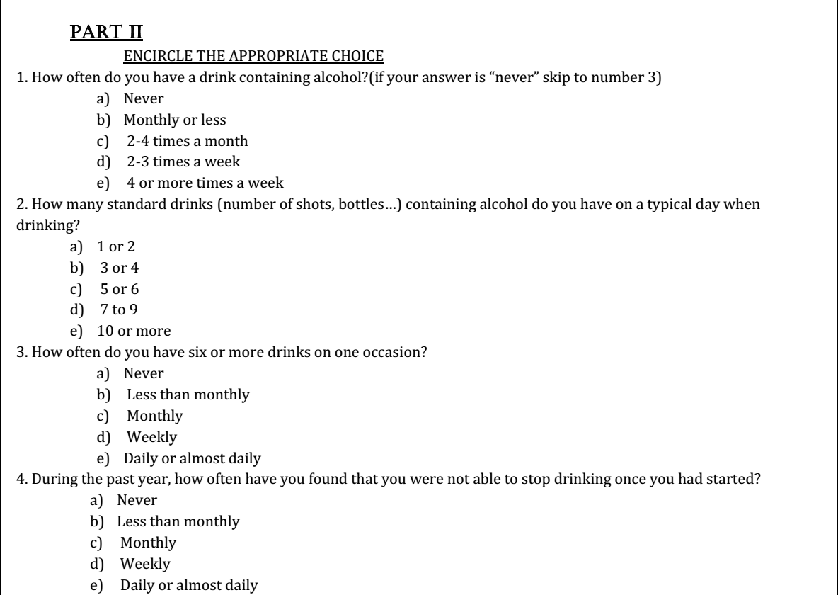
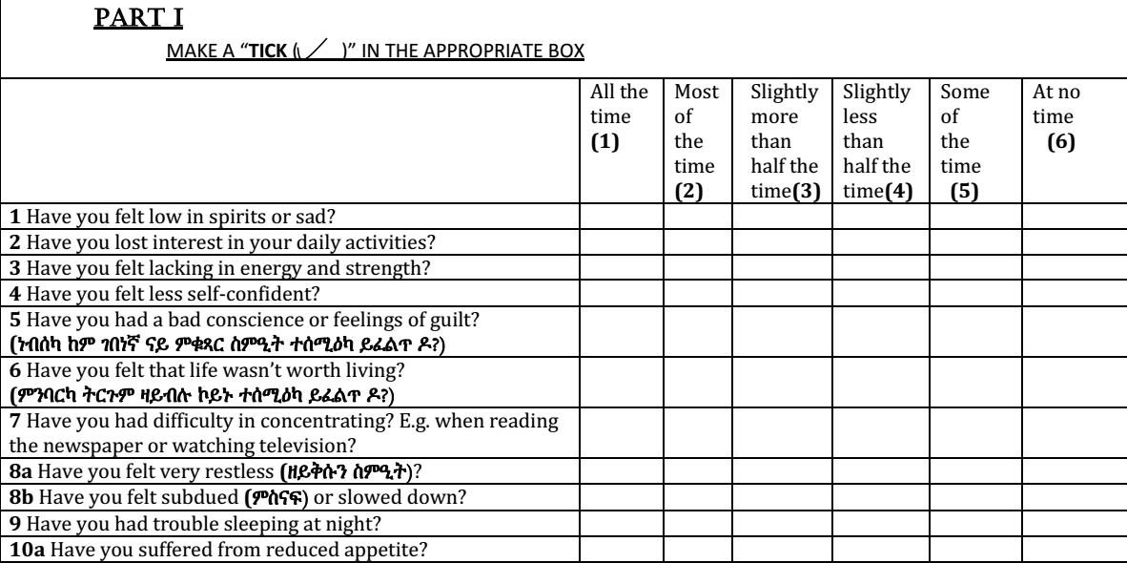
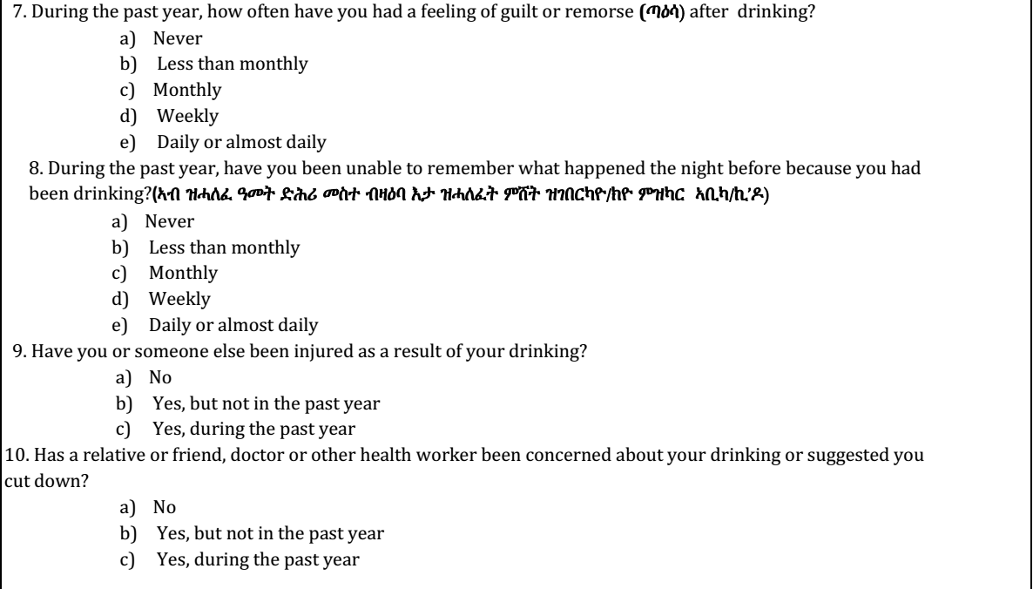
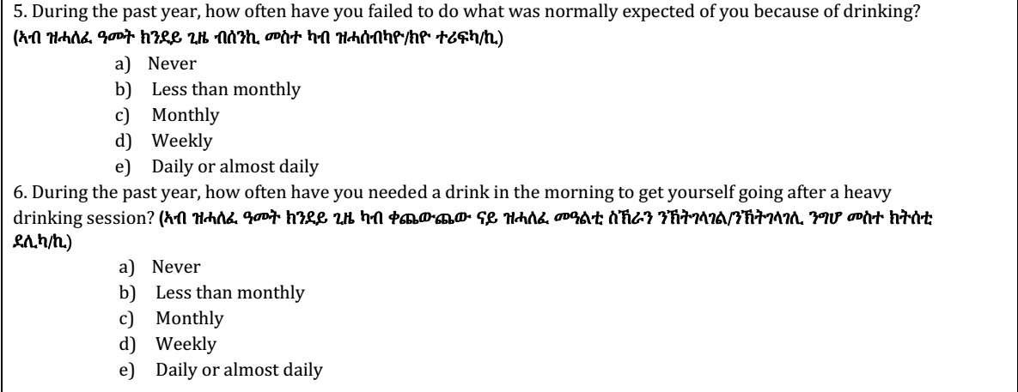
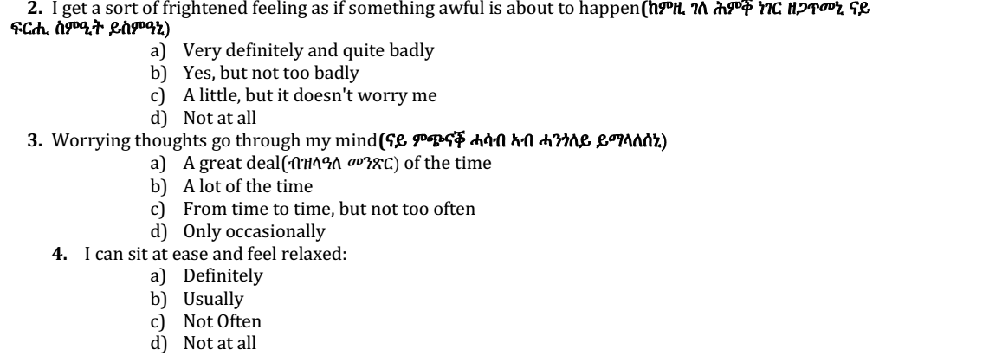
PART III
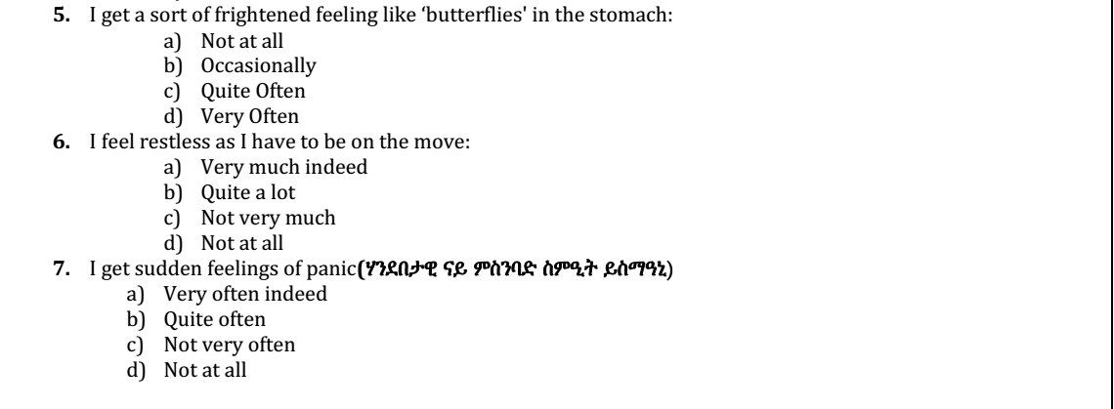


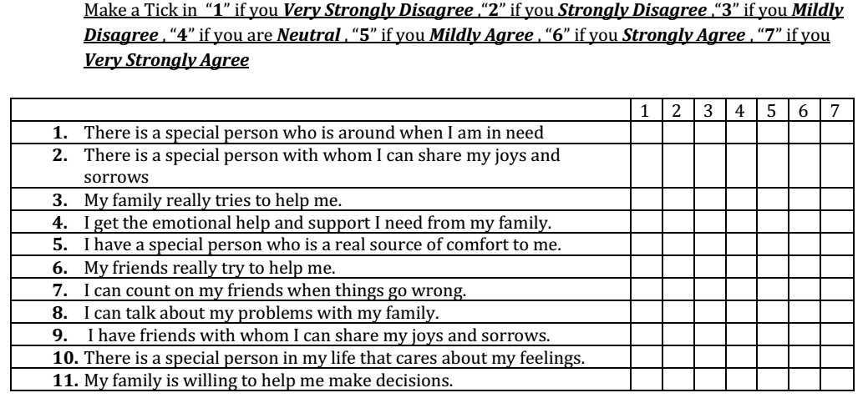
PART IV
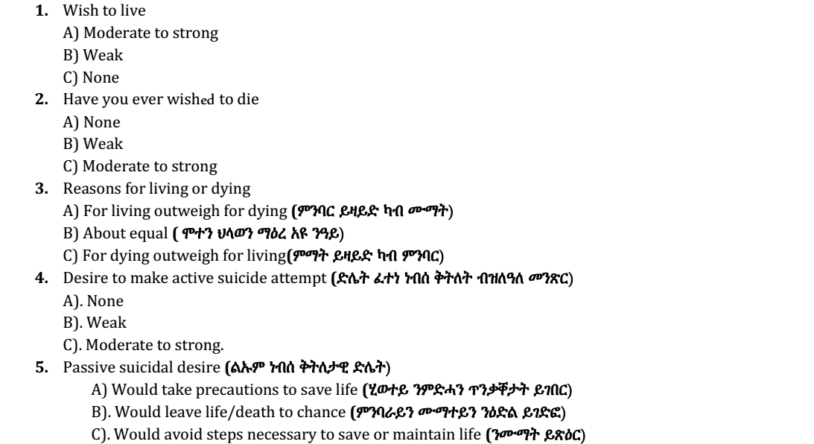
PART V
6. Duration of suicide ideation(thought) or wish (ሓሳብ ናይ ነብሰ ቕትሇት (ኣብ ሓሳብካ ዝጸንሓለ ግዜ))
A) None
B) Longer periods (ንነዊሕ ግዜ)
C) Continuous (chronic) or almost continuous (ቀጻሉ ወይ ብዝሌዓሇ መንጽር)
7. Frequency of suicidal thought (ክንዯይ ግዜ ብዛዕባ ነብሰ ቕትሇት ሓሲብካ)
A)Rare, occasional
B) Intermittent (ተዯጋጋሚ ግዜ)
C) Persistent or continuous (ቀጻሉ ግዜ)
8. Attitude toward ideation or wish (ኣረኣእያኻ/ኺ ብዛዕባ ሓሳብ ናይ ነብሰ ቕትሇት)
A) Rejecting
B) Ambivalent; indifferent (መንጎ መንጎ)
C) Accepting
9. Control over suicidal action or acting-out wish (ቁጽጽር ኣብ ሌዕሉ ፈተነ ነብሰ- ቕትሇት / ድላት)
A) Has sense of control (ስሚዒተይ ክቆጻጸሮ ይክአሌ )
B) Unsure of control (ርግጸኛ ኣይኮንኩን ብዛዕባ ናይ ምቁጽጻር ስምዒተይ)
C) Has no sense of control(ስሚዒተይ ክቆጻጸሮ ኣይክአሌ)
10. Deterrents to active attempt (e.g., family, religion, irreversibility) (ከሌካሉ ንፈተነ ነብሰ
ቅትለት)
A) Would not attempt because of a deterrent (ብሰንኪ እዞም ከሌከሌቲ ፈተነ ቕትሇት ኣይገብርን እየ)
B) Some concern about deterrents (ብዉሑድ መንጽር ይጸሌዉኒ እዞም ከሌከሌቲ)
C) Minimal or no concern about deterrents (ፈተነ ቕትሇት ንኽፍጽም ብፍጹም ኣይድሩትንን)
11. Reason for contemplated(thinking) attempt (ምኽንያት ናይ ነብሰ ቕትሇት ምሕሳብካ/ኪ)
A) None
B) To manipulate the environment; get attention, revenge (ኣቓሌቦ ንምስሓብ ወይ ሕነ ምፍዳይ)
C) Escape, surcease, solve problems
12. Specificity or planning of contemplated attempt (ውጥን ንነብሰ ቕትሇት)
A) Not considered ( ሓሲበ ኣይፈሌጥን)
B) Considered, but details not worked out (ሓሲበ ግን ዉደአ ውጥን ኣይነበረን)
C) Details worked out/well formulated(ሓሲበ ከምኡ ውን ዉደአ ውጥን ነይሩ)
13. Method , Availability/opportunity for contemplated attempt
A)Method not available; no opportunity
B) Method would take time/effort; opportunity not readily available
C)I Method and opportunity available
C)II Future opportunity or availability of method anticipated(ትንቢት)
14. Sense of "capability" to carry out attempt (ፈተነ ነብሰቕትሇት ንኽትገብር ዘሇካ ትብዓት)
A) No courage, too weak, afraid, incompetent (ተባዕ ኣይኮንኩን ወይ ፈራሕ እየ ነብሰይ ንኽቐትሌ)
B) Unsure of courage, competence (ርግጸኛ ኣይኮንኩን ብዛዕባ ትብዓተይ)
C)Sure of competence, courage (ርግጸኛ እየ ብዛዕባ ትብዓተይ ነብሰይ ንኽቐትሌ)
15. Expectancy/anticipation (ትጽቢት) of actual attempt (ኣብ መጻኢ ነብሰ ቅትሇት ትፍጽም ትኽውን ዶ?)
A) No
B) Uncertain, not sure
C) Yes
16. Actual preparation for contemplated attempt (ሓቀኛ ምድሊው ንፈተነ ቕትሇት)
A) None
B) Partial (e.g., starting to collect pills)
C) Complete (e.g., had pills, loaded gun)
17. Final acts in anticipation of death (e.g. will) (ሇበዋ)
A None
B) Thought about or made some arrangements (ንኽሊቦ ሓሲበ ወይ ገሇ ምድሊዋት ጌረ ኔረ)
C) Made definite plans or completed arrangements (ዉደእ ምድሊዋት ጌረ ኔረ)
18. Deception or concealment of contemplated suicide (ናይ ሓሶት ፈተነ ቕትሇት ምሕሳብካ)
A) None
B) Held back on revealing(ሓሳበይ ካብ ምግሊጽ ተቆጢበ ነይረ)
C) Attempted to deceive, conceal, lie(ናይ ሓሶት ፈተነ ቕትሇት ፈጺመ)

